SPRINT DATA:

A Randomized Trial of Intensive versus Standard Blood-Pressure Control
The SPRINT Research Group*
N Engl J Med 2015; 373:2103-2116November 26, 2015DOI: 10.1056/NEJMoa1511939
In September, 2015, the front pages of several newspapers such as The Washington Post and The New York Times declared that a landmark study supported more aggressive blood pressure targets. The SPRINT trial enrolled 9361 subjects with hypertension and without diabetes who were randomly assigned to standard treatment of hypertension to keep systolic pressure below 140, or more aggressive control of blood pressure to push it below 120. Those in the latter group received medicines, some of which (Beta Blockers and ACE inhibitors) may help reduce mortality independent of their blood pressure lowering effect, to lower blood pressure to the target range. According to the press, SPRINT proved the value of aggressive blood pressure reduction by decreasing death by 27%, cardiovascular death by 43%, and poor outcome by 25%. There were, according to the press, some adverse outcomes which were not measured. The following are BRCTs to represent the actual risks and benefits of aggressive blood pressure reduction from the SPRINT trial.
The blackened seats represent the additional number of people who died (3.5) in a year among 1000 people without intensive blood pressure management compared to 1000 people who had intensive treatment. The 996.5 empty seats represent the people who did not benefit from intensive treatment.
The number of people who avoided cardiovascular death with aggressive intervention was 2 out of 1000 (998 did not benefit), and who avoided poor health outcome (mostly new cardiovascular disease such as heart attack and congestive heart failure) was 5 out of 1000 (995 did not benefit)

The blackened seats represent the additional number of people who developed life threatening hypotension (3) in a year among 1000 people who had intensive blood pressure management compared to 1000 people who did not have intensive treatment.
The blackened seats represent the additional number of people who developed severe kidney disease in a year (6) among 1000 people who had intensive blood pressure management compared to 1000 people who did not have intensive treatment.

The blackened seats represent the additional number of people (over 20) who developed serious side effects in a year among 1000 people felt to be directly due to the intensive blood pressure management compared to 1000 people who did not have intensive treatment.
There was no good evidence about the number of side effects that were not life threatening such as dizziness, falls, worse memory, and fatigue, all of which are very common with aggressive blood pressure treatment and cause significant impairment especially in the elderly. Also, measuring blood pressure accurately is neither easy nor consistent and pressure tends to be higher in doctor offices.

OTHER DATA:
Several other studies show that in fact aggressive lowering of blood pressure may increase death or not change adverse outcomes. This was especially true among people with diabetes, kidney disease, or a past history of stroke or MI.
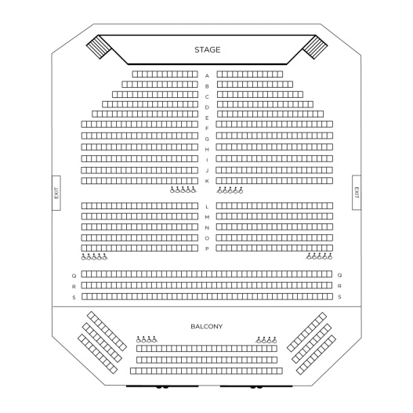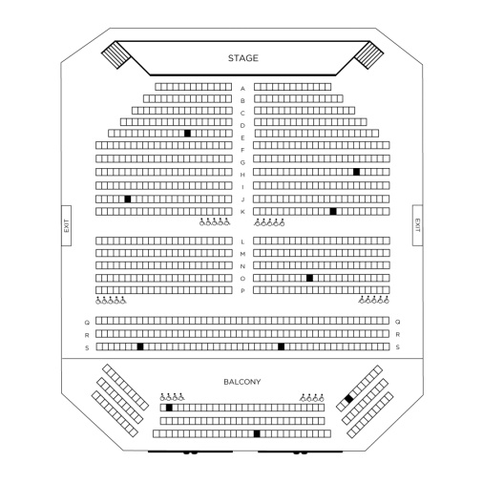
The ACCORD study of 4700 diabetics showed no significant change in outcome among diabetics aggressively treated for their blood pressure (0 seats), but did find a 20/1000 increase in serious adverse events from aggressive blood pressure management, which mirrors the findings of SPRINT. (first BRCT)
More recently, the HOPE-3 study (April, 2009) that evaluated 12,700 people with high blood pressure for over 5 years concluded: “our data are compatible with the hypothesis that treating persons without cardiovascular disease who have a systolic blood pressure above approximately 140 mm Hg appears to be beneficial, but treatment would not be of benefit and may be even harmful in persons with lower systolic blood-pressure levels.” In fact, out of 1000 people treated with medicine to push systolic BP below 130, 8 additional people have poor outcomes (heart disease or death) compared to 1000 people not treated aggressively. (second BRCT).

A list of a few studies that contradict the SPRINT data and show either unchanged or increased mortality with intensive blood pressure management are listed below.
Ovbiagele, “Level of Systolic Blood Pressure within normal range and risk of recurrent stroke,” JAMA, 2011, 306: 2137-44.
The ACCORD study group, New England Journal of Medicine, 2010, 362: 1575-85/
Cooper, “Tight Blood Pressure control and cardiovascular outcomes among hypertensive patients with diabetes and CAD,” JAMA,2010,304: 61-8.
Law, “Use of Blood Pressure lowering drugs in the prevention of cardiovascular disease,” BMJ, 2009, 338: 1665.
Messerli, “Dogma disputed: can aggressively lowering Blood Pressure in hypertensive patients with CAD be dangerous,” Annals of Internal Medicine, 2006, 144: 884-93.
Kovesdy, “Blood Pressure and mortality in US Veterans with chronic kidney disease,” Annals of Internal Medicine, 2013, 159(4): 233-42.
Lonn, E, (HOPE-3 Study Group), “Blood pressure lowering in intermediate-risk persons without cardiovascular disease,” New England Journal of Medicine, April 2, 2016.

Overall the data about aggressive blood pressure lowering is not definitive. Using BRCTs, and letting patients know that other studies exist that do not agree with SPRINT, will help patients and doctors make reasonable choices about optimal blood pressure management, especially when each patient’s individual side effects from aggressive blood pressure treatment are factored in.

