5. BRCTs
The core of this book consists of case studies on screening tests, drugs, surgeries and other forms of medical intervention. We have not conducted any of the research referenced in this book. We have used a unique graphic to present, in absolute terms, findings from recent, independent, robust studies. We believe our approach will encourage each patient to determine her/his level of individual acceptable risk. We believe our paradigm represents a much improved decision aid, with the potential for universal applicability. Due to its importance, significance and notoriety, we have selected breast cancer screening to illustrate why our approach may be of interest to the medical community and patients.
Recently, reports on the benefits and risks of mammograms have flooded the media. In articles, Op-Ed pieces and letters to the editor, prominent representatives from the medical community and articulate members of the public have eloquently expressed their views and perspectives on this subject. Some of these commentaries are diametrically opposed to screening – others fully embrace and support the use of mammograms, and some conclude there is too much uncertainty to make an evidence-based decision.
What is certain, however, is that the current attention given to mammograms will dissipate and women in the US and throughout the world will not be any closer to making an informed choice regarding what constitutes an acceptable level of individual risk. Why is this happening? Why are medical experts, in vitriolic terms, talking past each other? Why are women becoming more apprehensive and anxious rather than becoming empowered?
It is time to answer these questions if patients are going to meaningfully participate in decisions regarding the use of mammograms and many other medical tests and treatments. It needs to be acknowledged that many patients want to be in a position to make the final decision regarding medical intervention – such as whether to be screened for breast cancer.
A typical example of this seemingly endless problem can be found in a recent article in the NYT (Vast Study Casts Doubts on Value of Mammograms, 2/11/2014). This article focuses on the results of a large and meticulous Canadian study on the benefits and risks of mammograms. The study found that the death rates from breast cancer and from all other causes were similar in women who routinely underwent mammograms and those who did not.
The statistics were presented in easily digested, absolute terms: 1 woman in 1,000 who starts screening in her 40s, 2 who start in their 50s and 3 who start in their 60s will avoid a breast cancer death. Values presented this way are a first step to providing patients with an opportunity to evaluate their own individual acceptable risk levels based on their interpretation of the data.
But just presenting absolute numbers is unlikely to provide a woman with the ability to determine her individual acceptable risk level. The numbers have to be framed using a familiar context. Using a Breast Cancer Screening BRCT, this is how we would suggest presenting this information to a patient (Fig. 5.1).

Benefits of Breast Cancer Screening (Mammograms)
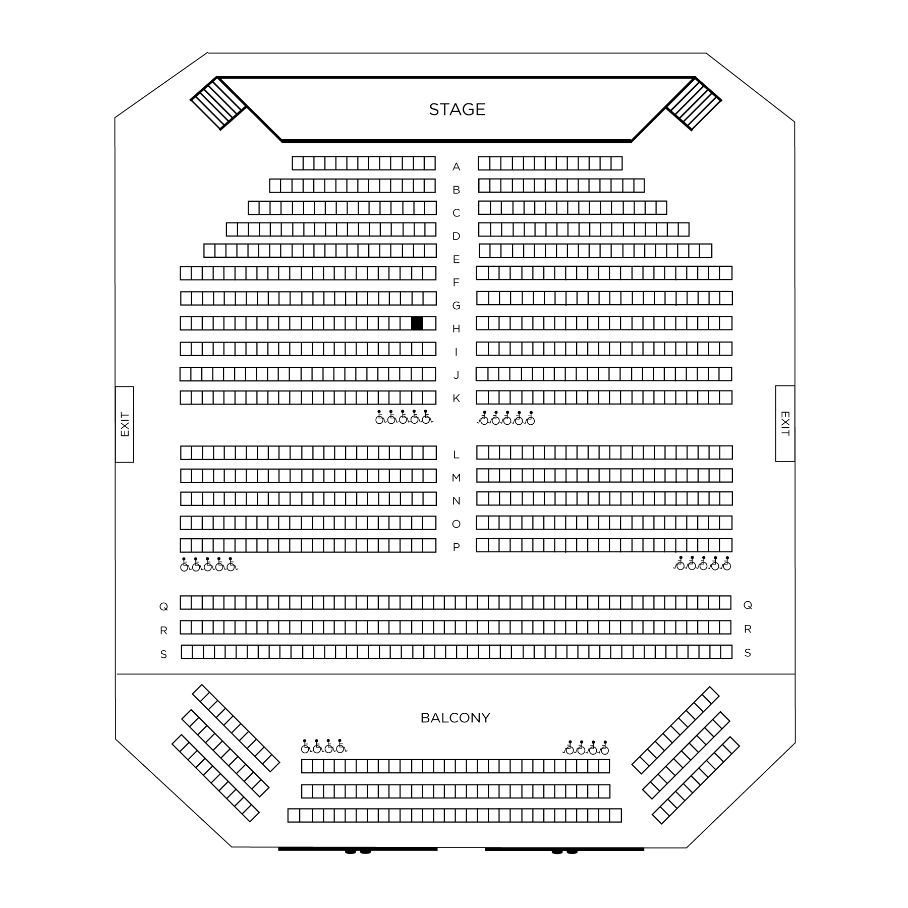
Fig. 5.1 If there were 1,000 women sitting in a theater who never had a mammogram over a lifetime, there will be approximately 1 additional death, represented by 1 blackened seat, over that time period, when compared to 1,000 women who did undergo screening over a lifetime.
Given the costs, inconvenience, unpleasantness and adverse impacts of mammograms many women may look at the BRCT and decide to forgo breast cancer screening, especially given the high false positive rate of mammograms . For example, among a thousand 50-year old American women screened annually for a decade, 490-670 will have at least 1 false alarm and 3-14 will be over diagnosed and treated needlessly. If this information were provided to women in a BRCT format, it would serve as an objective framework to assess and compare the risks of mammograms with the absolute survival advantage of having the test (see Chapter 6 on Mammograms).
Unfortunately, absolute numbers are rarely used by the press and medical community to characterize the risks and benefits of mammograms. As mentioned earlier, another statistical method (relative risks), is now routinely used to convey health risk and benefit information to the public. Case in point - In the same New York Times exchange mentioned above, Dr. Richard C. Wender, chief of cancer control for the American Cancer Society, used the relative risk approach when asked about the study’s findings, “… combined data from clinical trials of mammography showed it reduces the death rate from breast cancer by at least 15% for women in their 40s and by at least 20% for older women”. When compared with 1 in a 1,000, 15% - 20% makes it appear as though mammograms significantly reduce the incidence of breast cancer deaths. But what does 15% - 20% really mean?
One in 1,000 is something we can get our arms around - One person out of 1,000 benefits. We can picture ourselves in a theater with 1,000 other people and estimate the odds of our being the 1 person benefiting. But how does one assess the importance of reducing a death rate by 20%? There is no context within which a reasonable decision can be made. What if mammograms reduce death from 2/1000 to 1/1000? That is 50% reduction in death. Despite its seemingly impressive significance, 15-20% could, and usually does, constitute a very small benefit, as it does in the case of mammograms.
This is not a small technical point we are making. This problem is both serious and pervasive, and it drives a great deal of unnecessary, costly and potentially risky medical decisions. Given the emphasis being placed on SDM and the importance of communication between patients and doctors, more emphasis should be placed on the appropriate way to present findings to the public.
We need to reach a point where doctors, politicians, insurance companies, medical journals and government agencies demand that information be presented in ways that encourage patients to become more involved in decision making. A woman contemplating having periodic mammograms should request absolute benefit and risk values from her doctor in order to make an informed decision.
The following chapters consist of 19 case studies that include BRCTs for well-known screening tests, drugs, surgeries and other types of medical intervention. Each chapter has a consistent format. They begin with a brief ‘story’ which sets the stage; key question presented in bullet form; risks and benefits presented in bullet form as well; and relevant BRCTs. All of this information is presented in an easily digested format that enables doctors and patients to share material when addressing risks and benefits from medical intervention. The next section of each chapter, the discussion, is more technical and was written using medical terms and concepts more familiar to physicians. The last section contains references so that our sources for information contained in the BRCTs are readily available.
In this book, we have translated confusing statistics into meaningful absolute values that doctors and patients can mutually utilize to help guide decisions. By using our graphics, conversations about important medical tests and treatment can occur during an office visit in a time efficient and useful way. We hope this is a first step toward a more broad utilization of absolute-value decision aids in the health care industry.

